roid

217, Sheikh Rashid Building

P.O Box 56272, Dubai

United Arab Emirates

Tel: +971 4 2973236 / 04 2974007

Email: uae@verbat.com

Business Requirements

**Incident Management System**

|  |  |
| --- | --- |
| **Prepared for:**  **MIRAL** | **Submission Date:**  09 Apr 2018  **Proposal ID:** AD/BP/09042018/1343/1 |

________________________________________________________________________________________________________________________________  
Conﬁdentiality Notice: This Proposal is conﬁdential and contains proprietary information and intellectual property of Verbanet Technologies LLC. Neither this proposal nor any of the information contained herein may be reproduced or disclosed under any circumstances without the express written permission of Verbanet.

© 2018 by Verbanet Technologies LLC. All rights reserved. Confidential.

________________________________________________________________________________________________________________________________

**Table of Content**

1 Project Scope 8

1.1 IMS Features 8

1.2 Key Platform Stakeholders / “Actors” 10

1.2.1 First Responders / Reporters 10

1.2.2 Second Responders or IMS personnel: 10

1.2.3 Incident management process owners 12

1.2.4 Incident management Technician 13

1.2.5 Incident Coordinators 13

1.2.6 System Administrators 14

1.3 Business Requirements 14

1.3.1 Master Data Management (MDM) 14

1.3.2 Message Content 17

1.3.3 Real time Collaboration (In-App Chat) 18

1.3.4 Message acknowledgment 18

1.3.5 Message Tracking 18

1.3.6 Report Generation 18

1.3.7 Offline reporting (SMS) 18

1.3.8 Voice calling 18

1.3.9 Hot numbers 19

1.3.10 Panic Button 19

1.3.11 Dashboard view 19

1.3.12 Admin 19

1.3.13 Notifications 20

1.3.14 Incident Reporting 20

1.3.15 Complaint Routing 20

1.3.16 Efficient processing 20

1.3.17 Easy Customization 21

1.3.18 Security Features 21

1.3.19 Flexibility 21

1.3.20 Automatic Call Escalation 21

1.3.21 Dynamic Business Rules 22

1.4 Business process models 23

1.4.1 Incident Management Process Sequence 23

1.4.2 Incident Management Workflow and user tasks 24

1.4.3 Incident logging and categorization 25

1.4.4 Incident Assignment 26

1.4.5 Incident Investigation and Diagnosis 27

1.4.6 Incident Resolution and Recovery 28

1.4.7 Incident Closure 29

1.4.8 Incident Escalation 30

1.5 IMS High Level Architecture 31

1.6 Constraints 32

1.6.1 Inclusions 32

1.6.2 Exclusions 32

1.6.3 Dependencies 32

1.6.4 Key Assumptions 32

1.6.5 Key Risks and Issues 32

1.8 Critical Success Factors 33

1.9 System Interfaces 33

**Document Revision History**

|  |  |  |  |  |
| --- | --- | --- | --- | --- |
| **Version #** | **Date** | **Requestor** | **Revised By** | **Change Description** |
| 0.1 | 09/04/2018 |  | Prashant Thomas | Initial Version |
|  |  |  |  |  |
|  |  |  |  |  |
|  |  |  |  |  |

***Note:***

*Standardized version numbering convention:*

*Drafts – (Before approval signature)*

*0.#*

*0.#+1*

*Published – (Once there is an approval on the document)*

*1.0*

*1.#*

**Glossary of Terms**

|  |  |
| --- | --- |
| **Term/Acronym** | **Definition** |
| IMS | Incident Management System |
| First Responder / Reporter/ Witness / Level 1 responder | An individual who shall use a mobile application to report an incident |
| Level 2 Responders | Users who receive the request and resolve it by responding to it by taking an appropriate action |
| Escalation | An Activity that obtains additional resources when these are needed to meet service level targets or user expectations. |
| Group | A number of people who are similar in some way. People who perform similar activities, even though they may work in different departments |
| Hierarchic Escalation | Informing or involving more senior levels of management to assist in an escalation. |
| Impact | A measure of the effect of an Incident, Problem, or Change on Business Processes. Impact is often based on how Service Levels will be affected. Impact and urgency are used to assign priority. |
| RACI Matrix | A responsibility matrix showing who is Responsible, Accountable, Consulted and Informed for each activity that is part of the Incident Management process. |
| Incident Management | The process responsible for managing the lifecycle of all Incidents. |
| Priority | A category used to identify the relative importance of an Incident, Problem or Change. Priority is based on impact and urgency and is used to identify required times for actions to be taken. For example, the SLA may state that Priority 2 Incidents must be resolved within 12 hours. |
| Priority 1 Incident | The highest category of impact for an Incident which causes significant disruption to the business. A separate procedure with shorter timescales and greater urgency should be used to handle Major Incidents. |
| Competency | Functional areas of expertise that relate specifically to tactical operations managed. |
| MDM | Master Data Management |

# Project Scope

The Incident Management System (IMS) is a project in (YAS Islands or Miral properties) to send pictures and incident information from a first responder/Reporter on the scene to secondary responders (e.g. Police, Fire & Rescue, Traffic or Sanitation). The information is provided directly to off-site supervisors, enabling them to make faster and more accurate responses of their resources without having to travel to the incident scene first.

The system being developed shall consist of 3 subsystems

* A mobile application (Android & IOS) that shall be used by witnesses to report the incident. This App will be deployed for all Miral Projects and operational assets (Miral Staff, Contractors and YAS Partners)
* A desktop application that is used by Level 2 responders, that shall resolve the incident by taking appropriate action ( such as routing to the concerned department, mobilizing units to resolve the incident, escalate the incident to involve various other departments). A mobile version of the application (Android & IOS) may also be made available to field staff with appropriate functionality.
* A server side application with intelligence to apply context, severity, priority to the reported incident. The application will have tertiary functions such as Speech to Text, identify departments involved and auto route the request to the concerned department of personal.

## IMS Features

The IMS being developed shall have the following features

* **Friendly UI -** Provide a user‐friendly interface that can be learned quickly with minimal training –The software shall behave in a way that is intuitive.
* **Mobile capabilities** – The mobile application shall be smart enough to identify the location, use multiple channels (mobile providers, wireless, SMS, Bluetooth, Mobile networks) to communicate, be able to receive notifications, Multiple formats to encode messages, must have emergency calling, with panic buttons, context sensitivity and auto dialing
* **Application integrations** – The mobile application must have essential integrations with SMS, email, messaging or chat, GPS, camera and microphone. Backend systems shall be integrated to reporting, document generation, databases, external systems like ERP
* **Access Control** - Support multiple access levels with configurable role‐based security mechanisms –Setting access controls based on an individuals’ role will be key to ensuring your processes are moving smoothly.
* **Track multiple, concurrent incidents** – Incidents may be related to each other. In such cases the system shall be able to link the incidents, track them and treat them as closed only after all incidents are closed
* **Configurable notification options** – It is important that the incident management system supports email, voice and SMS notifications so that it can reach out through multiple channels.
* **Customization to support existing workflows** – Incident management systems have a generic workflow whose elements are common across similar implementations. However each system has its own distinct makeup or features. That is because each organization has its already established processes and the role of an incident management solution should be to make that process more efficient and reportable, not to force a new set of procedures on an organization.
* **Ability to share, request and submit information between stakeholders** ­– Incident management software must provide the option to track multiple incidents simultaneously, yet separately. Interoperability is crucial, and being on an island when it comes to the ability to interface with mutual stakeholders.
* **Display summary information visually across the system** – The notion of situational awareness and dashboards are more than buzzwords, they are imperative. An incident management solution should include a visualization tool that can enable you to arrange a combination of information sets in one place, and allow you to decide what’s important enough to be there.
* **Task management and assignment** – IMS shall be able to track their resources. IMS should allow for resource requests and task assignments to be submitted from the field or on-site, and then be routed to the appropriate position.
* **Mapping capability** ­– IMS shall allow the visualization of resource deployments on a map. Being able to visualize these locations and their status on a map, without requiring the need for specialized GIS expertise, is key characteristic to good incidence response.

## Key Platform Stakeholders / “Actors”

### First Responders / Reporters

Reporters report an incident. They may belong to the general public or be part of the incident management taskforce. They shall use a mobile application to report concerns related to public safety, police, streets, water, sewer service etc. as well as provide feedback & suggestions. They shall use the application to

* Autodial , Dial by voice or dial using panic buttons
* Send messages using text, audio, image, video. Images and videos may be recorded live or use existing content in the mobile device
* Send messages by taking advantage of the available communication media (Mobile networks, SMS, wireless, blue tooth)
* Encode additional information in messages such as geo-location, geo-fencing, senders credentials, time and date, infer key words from messages whether it be via text, audio or video
* Receive notifications via Chat, SMS, Mobile Push, Phone calls, Email

### Second Responders or IMS personnel:

Incidents can be single command incidents or Unified command incidents. For example in the event of a building fire, fire fighters should be deployed along with paramedics and /or police. In such situations it is important that someone is in charge of the overall operation.

Typically this involves the establishment of a command and control similar to the diagram depicted below

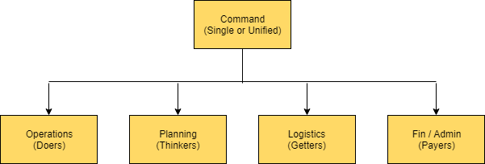

The various elements of the structure are

**Command**: The Command Element is responsible for overall incident management and has the authority to make strategic and tactical decisions regarding the mitigation of the incident, define the Incident Objectives and determine what resources are required for the incident. The Command Element is responsible for working collaboratively with the Primary, Coordinating and Supporting Agencies to set Incident Objectives and priorities and is accountable for the effective deployment of available resources.

**Operations:** Operations is responsible for all tactical operations at the incident. Includes Branches, Sectors and / or Groups, Task Forces, Strike Teams, Single Resources, and Staging Areas.

**Planning**: Planning is responsible for the collection, evaluation, and dissemination of tactical information related to the incident, and for the preparation and documentation of Incident Action Plans. The Planning Section also maintains information on the current and forecasted situation and on the status of resources assigned to the incident.

**Logistics:** Logistics is responsible for providing facilities, services, and materials for the incident.

**Finance / Administration**: Section is responsible for tracking incident costs, personnel and equipment records, claims, procurement contracts and providing legal expertise and counsel, as needed. Most incidents will not require implementation of an on-site Finance / Administration Section. Instead incident costs will be tracked by the agencies providing personnel, equipment and support services to the incident.

Depending on the requirements, the IMS being implemented may not require a full complement of the hierarchy discussed above, but it will need to establish the basic elements of the paradigm discussed.

The following stakeholders have been identified in the initial requirement study, however their roles, entitlements and titles, competency (i.e. their department) etc. need to be established to determine the functionality needed.

### Incident management process owners

The process owner uses the application and performs the following functions

* The process owner defines SLA and KPI for the incident management system
* The process owner audits the process to ensure compliance to policies and standards
* Identifies and addresses issues with the process
* Ensures that the process, roles and responsibilities are regularly reviewed and audited
* Functions as a point of escalation

### Incident management Technician

Tier 1 Technicians are the line staff who are the subject matter experts for assessing, planning and monitoring Incident Management for their functional organization and/or specific technology platform. They function as initial contact between those reporting incidents and the incident management system. Technician is the initial contact with those reporting incidents and provides triage and resolution.

The process manager

* Provides the resolution of Incidents in a proper and timely manner as it is the end-responsibility of Incident Management. Ensure that Incidents are resolved in a proper and timely manner and the resolutions adhere to objectives set forth in Service Level Agreements
* Monitor the Incident Management process, using qualitative and quantitative Key Performance Indicators and make recommendations for improvement
* Escalate to Line Management if Service Levels are threatened to be breached
* Escalate incidents they cannot resolve within agreed timescales
* Audit the Incident Management process
* Log relevant incidents
* Categorize and prioritize incidents when appropriate (if different from what the system reported)
* Close all assigned and resolved incidents
* Communicate with users and inform them of incident progress
* Take ownership of incidents when needed

### Incident Coordinators

Incident Coordinators are the line staff who are responsible for the planning and monitoring of the Incident Management process. They function as contact people between the different departments for a specific process and may be responsible for the design of processes within their own departments.

Their main functions include

* Validates, accepts and assigns Incident records to Tier 2 Incident Technicians
* Closing all assigned and resolved Incidents
* Determine whether an Incident record requires special reporting
* Initiate the Verify, Document and Close process

### System Administrators

They shall be responsible for the following

1. Creating master data
2. Managing users
3. Managing the application

## Business Requirements

### Master Data Management (MDM)

The application shall need the following master data to manage the application

#### Responders

|  |  |  |  |  |  |  |  |  |
| --- | --- | --- | --- | --- | --- | --- | --- | --- |
| Responders (Expandable) (Receive) | | | | | | |  |  |
| UID | **Entity** | **First Name** | **Last Name** | **Mobile No** | **email** | **Competency** | **Role** | **Entitlements** |
| Miral-009 | Miral | Aboobacker | Abdul Razak | xxxxxxxxxx |  |  |  |  |
| Miral-098 | Miral | Al Shehhi | Abdulla |  |  |  |  |  |
| Miral-089 | Miral | AlBreiki | Ahmed |  |  |  |  |  |
| Miral-060 | Miral | Naushad | Ahmer |  |  |  |  |  |
| Miral-065 | Miral | AlHashmi | Ali |  |  |  |  |  |
| Miral-061 | Miral | Nimer | Ali |  |  |  |  |  |
| Miral-091 | Miral | Shukla | Amit |  |  |  |  |  |
| Miral-040 | Miral | Al Dhaheri | Amna |  |  |  |  |  |
| Miral-100 | Miral | Ferrier | Andrew |  |  |  |  |  |
| Miral-045 | Miral | Kiran | B.R. |  |  |  |  |  |
| Miral-016 | Miral | Ghawi | Basel |  |  |  |  |  |
| Miral-094 | Miral | Stanciu | Catalin |  |  |  |  |  |
| Miral-010 | Miral | DeVilliers | Chantel |  |  |  |  |  |
| Miral-086 | Miral | Schreiber | Chyna |  |  |  |  |  |
| Miral-095 | Miral | Munro | Claire |  |  |  |  |  |
| Miral-007 | Miral | Bontemps | Clement |  |  |  |  |  |
| Miral-037 | Miral | Goh | Cynthia |  |  |  |  |  |
| Miral-090 | Miral | AbdulWahab | Dalia |  |  |  |  |  |
| Miral-075 | Miral | Wills | Daniel |  |  |  |  |  |

#### Roles

Currently identified roles are

1. Reporters
2. Responders

#### Incident categories

Following incident categories have been identified, but provision shall be made to add more categories

1. Project
2. Operational Asset
3. Event
4. Media
5. Destination Yas
6. Guest Related

#### Incident Locations

Following incident locations have been identified, but provision shall be made to add more locations

1. Miral HQ
2. Miral Site Dar Site Office
3. Miral Site WB Site Office
4. WB TP Project
5. WB Car Park Project
6. Clymb
7. Zeina Complex
8. Muneera Complex
9. Destination Yas
10. Others

#### Incident Types

Following incident types have been identified, but provision shall be made to add more incident types

1. Fatality
2. Injury
3. Medical Emergency
4. Fire
5. Structural collapse
6. worker welfare violation
7. HSE violation
8. Security violation
9. Near Miss
10. Media coverage
11. Social Networks
12. Guest Experience
13. Crowd Surge
14. Crowd Fights
15. Power Failure
16. Utility Failure
17. Bomb Threat
18. Medical Emergency
19. Suspicious Package
20. Weather Alert
21. Others

#### Incident Stage / Status

Incident Status / Stage help identify the status or progress of the incident and its resolution

They can have been of the following but new status can be added if needed

1. New
2. Acknowledged
3. pending
4. Closed

"Only The originator /Admin can close incidents

#### Incident Severity

Incident severity helps to classify and prioritize the incident based on the damage caused

They are of the following, but can be expanded to accommodate more types

1. 8-10 :Severe
2. 4-7 L2:Significant
3. 1-3 L3 :Minor

There shall be an option to Auto fill according to incident type for example Fire, Fatality will be Severe by default. Incident level can be changed during its lifecycle and therefore the notifications and workflows related to it.

#### Notification Channels

The following notification channels shall be used by the application

1. App Notifications
2. App Alerts*: Tune shall be configured according to the severity of the alert and it shall override the phone settings if it has been changed to silent mode or even if the app notifications or alerts have been turned off
3. Email
4. SMS
5. Voice call (mobile)
6. Voice call via App

There shall be an option to allow channels to cascade according to severity level of the incident. The order is detailed below

**Minor incident**: SMS -> email -> App Notification (if not acknowledged) then App alert after 5 Minutes -> mobile call after 5 Minutes

Repeat the same cycle after 5 Minutes till acknowledgment is received

**Significant Incident**: SMS -> email -> App Notification + App alert for (if not acknowledged) -> mobile call after 4 Minutes -> Repeat the same cycle after4 Minutes till acknowledgment is received

**Severe Incident**: SMS -> email ->App Notification + App alert+ mobile call (if not acknowledged) Repeat the same cycle after2 Minutes till acknowledgment is received

### Message Content

The mobile application used by the reporter shall send messages with the following options made available

* Share photo of incident
* Share Video of incident
* Share location of incident
* Record audio or video information directly through the app
* Add remarks or comments about the incident

### Real time Collaboration (In-App Chat)

The mobile application shall have the ability to allow chatting between users of the app. Reporters can use the In-App chat feature to freely communicate with other users

### Message acknowledgment

A message that has been send via the App shall show a receipt for acknowledgement once the recipient has received and seen the message

### Message Tracking

Messages shall be tracked based on their status. The recipient of the message shall change the status of the message based on the action taken

### Report Generation

The application shall generate reports based on user activity. Reports shall be downloaded in excel format

### Offline reporting (SMS)

The app shall allow for offline reporting using a code generated by the application

### Voice calling

The app shall allow the user to voice dial another recipient of the app

### Hot numbers

Hot numbers shall be configured within the application to call police, ambulance, hospital, civil defense etc.

### Panic Button

A panic button shall be provided that dials out and / or send SMS message to a predefined number. The SMS message will have additional information such as geo location, ambient temperature etc.

### Dashboard view

The App shall have high level graphical dash board per project/incident type/user/location /time etc. for management /Admin reference. Intuitive dashboard shall offer real-time insight into complaint status & in-depth performance reports. Staff shall be able to monitor progress, resolve issues & update citizens via IM or push notifications.

### Admin

#### User Mapping

Admin shall have the ability to map users to user groups

#### Search

Admin Shall be able to search all reported incidents based on advanced filters like category, severity etc.

#### Add / modify /delete

Admin shall have the flexibility to add/remove /Modify Category, location, incident Type, Users, contact details ,Call cascading per severity, Cascading delay Time, Hot Numbers

#### Maintenance

Admin should have the flexibility and the privilege to carry all routine tasks and referral to the developer shall only be for maintenance or structural changes

### Notifications

Users can customized their preferred Notification channels as per incident level/Location with minimum mandatory channels for each level

### Incident Reporting

* The App shall be used to report incidents @ all Miral’s Projects and Operational assets.
* Destination YAS in general
* The App shall be available to Miral Staff, Miral subsidiaries staff, Miral contractors, Selected Destination YAS partner’s staff.

The following reports shall be provided

1. Number of requests made using the app versus requests received otherwise
2. Number of incidents reports per category/department/severity etc.
3. Incidents resolved vs incidents reported
4. Incident satisfaction report
5. Incidents resolved that meet the SLA
6. Activity log indicating calls received, calls answered etc.

### Complaint Routing

The system shall be able

* Resolve citizen requests quickly with intelligent request submission flow & notifications to relevant authorities.
* Allocate the correct person, team, or official based on nature of complaint, category, location or priority.

### Efficient processing

The system shall

* Streamline process flow right from the time a complaint is reported until it is resolved.
* Users shall be able to manage and track progress of request from submission & inspection all the way to resolution ensuring transparency & accountability.

### Easy Customization

The system shall be able to allow admins to

* Allow automated notifications to alert users about request status
* Manage users and access to the app with user filtering and blocking.

### Security Features

The system shall be

* Designed for compliance with data protection and investigation protocols.
* Secure & safe communication with authorities.
* Secure online desktop and database access for managing reports.

### Flexibility

The system shall

* Integrate other services as and when needed with complete flexibility to work with additional departments at any time.
* Provide additional functionalities to users at country, city or council level.

### Automatic Call Escalation

The system shall be able to

* Set up flows to automatically escalate to a manager after a period of time, even while the on-call staff members are still being alerted.
* Copy stakeholders and managers when there is a critical issue, or when an SLA threshold has been breached.

### Dynamic Business Rules

Workflows based on business rules shall support “if/then” scenarios, pre-set mutual aid agreements, standard recommendations for event type, and other predetermined situations.

## Business process models

### Incident Management Process Sequence

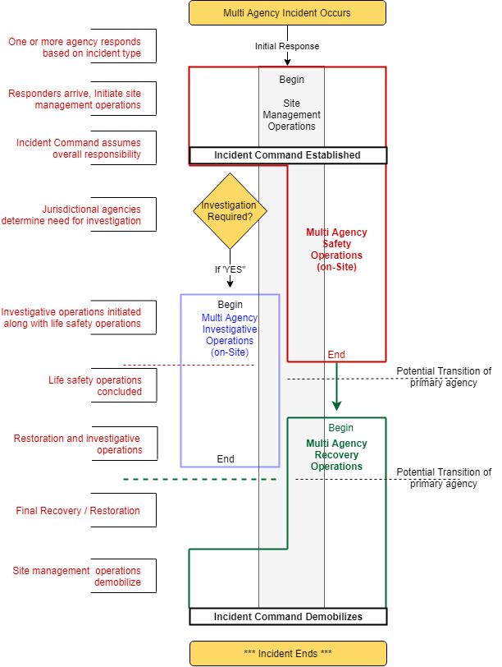

### Incident Management Workflow and user tasks

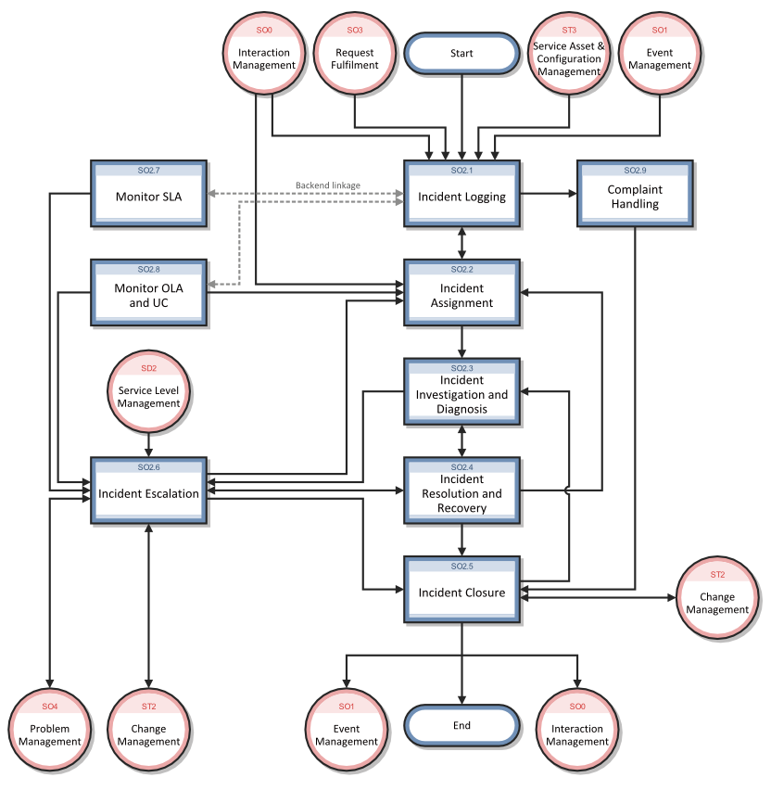

### Incident logging and categorization

Incidents are initiated and logged as part of the Interaction Management process or as part of the Event Management process, depending on the source and nature of the incident. All relevant information relating to incidents must be logged so that a full historical record is maintained. By maintaining accurate and complete incident records, future assigned support group personnel are better able to resolve recorded incidents.

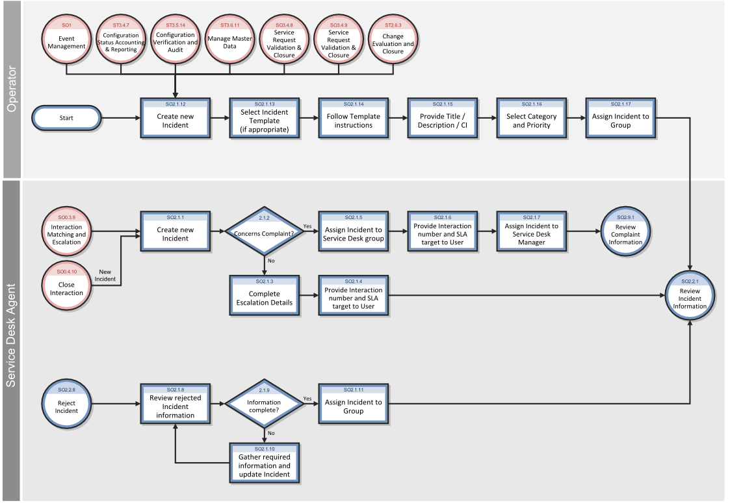

### Incident Assignment

Incident records are logged from an interaction by a Service Desk Agent or from an event by an Operator. The Incident Coordinator monitors the incident queue, reviews open status incidents, and determines from the information provided whether to accept or reject incident records. When an incident record is accepted, it is assigned to an Incident Analyst for further investigation and diagnosis.

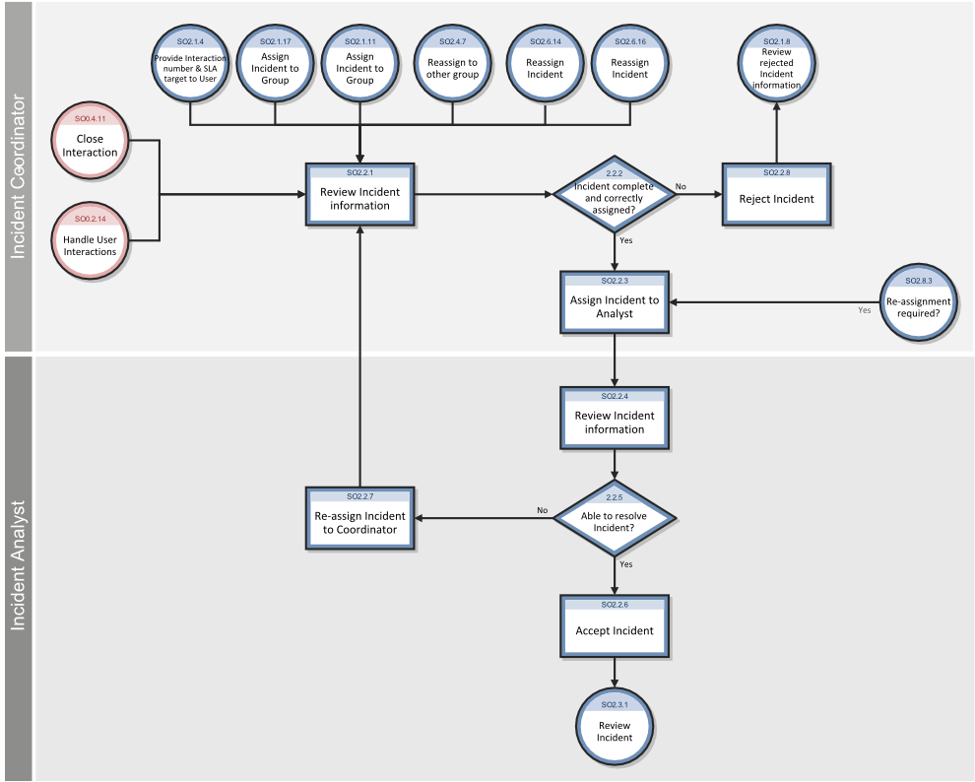

### Incident Investigation and Diagnosis

Each support group involved with handling incidents must perform investigation and diagnosis tasks to determine the cause and solution to the incident. All actions performed by support group personnel are documented in the incident record, so that a complete historical record of all activities is maintained at all times.

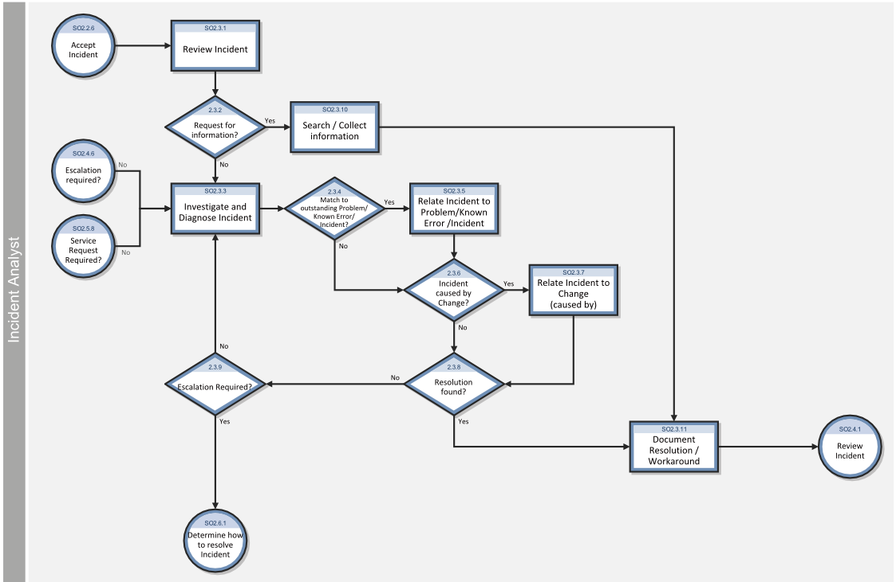

### Incident Resolution and Recovery

As part of the incident resolution and recovery process, the Incident Analyst identifies and evaluates potential resolutions before those resolutions are applied and escalates incidents as necessary. The Incident Analyst may escalate incidents to the Incident Coordinator, including those incidents that require a change. If the Incident Analyst does not have the required level of permissions to implement a change, the Incident Analyst reassigns the incident to another group that can implement the resolution.

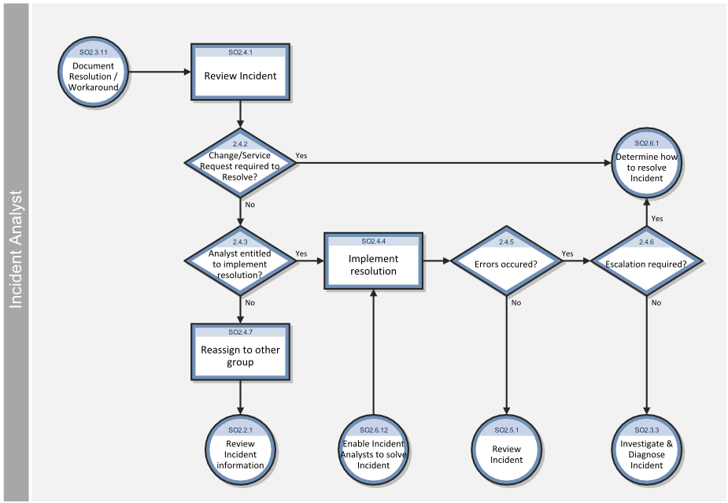

### Incident Closure

To close an incident in two steps, administrators need to configure the system to enable a two-step close process for incidents. In the two-step close process, a technician starts the close process when work on the incident is complete. The record is resolved, but not closed until an operator contacts the user and confirms the resolution. The operator then finishes closing the incident and the incident is inactivated.

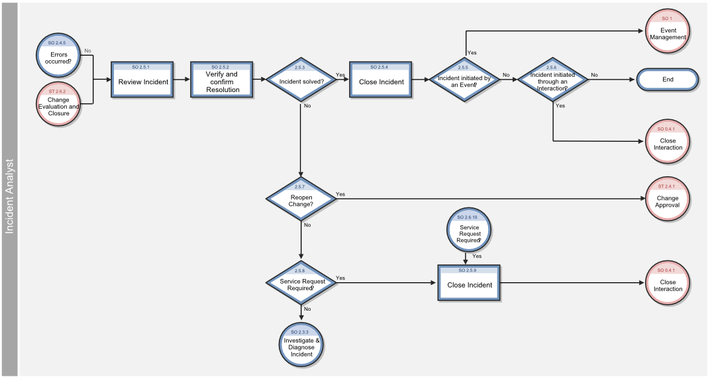

### Incident Escalation

When an Incident Analyst is unable to solve an assigned incident within the target time, the analyst escalates the incident to the Incident Coordinator. The Incident Coordinator determines how the incident can best be resolved by consulting the Incident Analyst and, if needed, other Incident Analysts. If an incident is severe (for example, designated as Priority 1), the appropriate managers must be notified so that they can anticipate and prepare for an escalation.

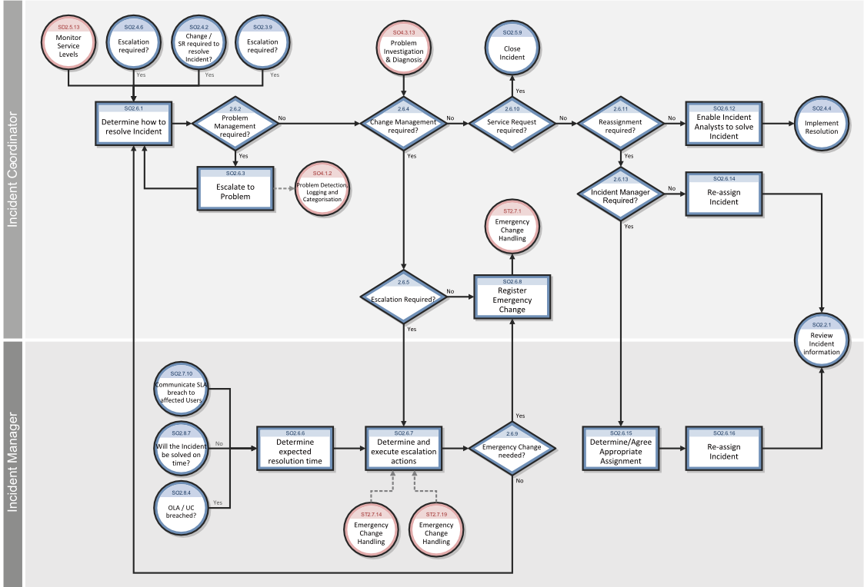

## IMS High Level Architecture

## Constraints

### Inclusions

Provide a high level summary of what is to be included (in scope) for project completion.

### Exclusions

Provide a high level summary of what is to be excluded (out of scope) for project completion.

### Dependencies

Provide a high level summary of any known project dependencies.

### Key Assumptions

Provide a high level summary of known assumptions about the project. Assumptions are factors that, for planning purposes, are considered to be true, real, or certain without proof or demonstration.

### Key Risks and Issues

Provide a high level summary of any known project risks. A risk is an uncertain event or condition that, if it occurs, has a positive or negative effect on a project’s objectives An issue is an event or circumstance that has occurred with project impact and needs to be managed and resolved.

## Critical Success Factors

CSFs are measurable, qualitative criteria, listed in order of importance, that when present in the project’s environment are most conducive to the achievement of a successful project. Often a business sponsor’s acceptance criteria will drive the CSFs for the project. The nature of these factors will govern the response to conflicts, risks, and setting of priorities. CSFs are highly dependent on the type of complexity of the project at hand. Examples include: Project implemented on time and within budget; Service Level Agreements are met; interfaces between ABC and XYZ work per specifications; ABC reports are produced as required; all service codes are verified during ABC process according to systems design; Phone Bank reps have been properly trained; Business Continuity Planning designed into the platforms; etc. Key Success Indicators are quantitative criteria by which success will be measured in some way, at some time, on some scale.

|  |  |  |
| --- | --- | --- |
| **Critical Success Factor** | **Key Success Indicator** | **Action Steps to Assure Success** |
|  |  |  |
|  |  |  |
|  |  |  |
|  |  |  |

## System Interfaces

|  |  |  |  |
| --- | --- | --- | --- |
| **#** | **System** | **Interface** | **Impact** |
|  |  |  |  |
|  |  |  |  |
|  |  |  |  |
|  |  |  |  |

We look forward to hearing from you soon and hope that you will give us the privilege to work with you in meeting your business goals. Thank you.

Thank You



©   
1999 - 2017. All Rights Reserved   
Verbanet Technologies LLC  
www.verbat.com